EX NO: | MODERN USER INTERFACE DESIGN USING REACTJS
DATE | 17/09/2026
Github Host
Link

AIM:

To design and develop a modern, responsive user interface using ReactJS with user registration form validation and page navigation using React.

Description:

- ReactJS is a JavaScript library used to build interactive and dynamic user interfaces for web applications.

- ReactJS follows a component-based architecture, allowing the UI to be divided into reusable components.

- JSX allows developers to write HTML-like syntax within JavaScript.

- React Hooks such as `useState` are used to manage component state and handle user interactions.

- Controlled form components are used to collect user details and validate registration form fields.

- CSS is used to create a modern and responsive design with attractive colors, layouts, buttons, and form elements.

- React Router is used to navigate between different pages without reloading the entire web page.

- Conditional rendering is used to display validation errors and successful registration messages.

- Responsive design techniques ensure that the application works properly on desktops, tablets, and mobile devices

Program:

<!DOCTYPE html>
<html lang="en">
<head>
<meta charset="UTF-8">
<meta name="viewport" content="width=device-width, initial-scale=1.0">
<title>Movie Reviews Blog</title>

<style>
* {
margin: 0;
padding: 0;
box-sizing: border-box;
}

body {
font-family: Arial, sans-serif;
background: #f4f4f4;
color: #333;
}

header {
background: #1a1a2e;
color: white;
text-align: center;
padding: 25px;
}

header h1 {
color: #ffcc00;
margin-bottom: 10px;
}

nav {
background: #16213e;
padding: 15px;
text-align: center;
}

nav a {
color: white;
text-decoration: none;
margin: 15px;
font-weight: bold;
}

nav a:hover {
color: #ffcc00;
}

.search-box {
text-align: center;
padding: 25px;
}

.search-box input {
width: 80%;
max-width: 450px;
padding: 12px;
border: 1px solid #ccc;
border-radius: 5px;
}

.container {
display: grid;
grid-template-columns: repeat(auto-fit, minmax(250px, 1fr));
gap: 20px;
padding: 25px;
}

.movie-card {
background: white;
border-radius: 10px;
overflow: hidden;
box-shadow: 0 4px 10px #ccc;
transition: transform 0.3s;
}

.movie-card:hover {
transform: translateY(-5px);
}

.poster {
height: 180px;
background: #222;
color: #ffcc00;
display: flex;
justify-content: center;
align-items: center;
font-size: 24px;
font-weight: bold;
}

.movie-info {
padding: 20px;
}

.movie-info h2 {
margin-bottom: 10px;
color: #1a1a2e;
}

.rating {
color: #e6a800;
margin-bottom: 10px;
font-weight: bold;
}

.movie-info p {
line-height: 1.5;
margin-bottom: 15px;
}

button {
background: #e94560;
color: white;
border: none;
padding: 10px 15px;
border-radius: 5px;
cursor: pointer;
}

button:hover {
background: #c72c48;
}

.review {
display: none;
margin-top: 12px;
padding: 10px;
background: #f0f0f0;
border-radius: 5px;
}

footer {
background: #1a1a2e;
color: white;
text-align: center;
padding: 20px;
margin-top: 20px;
}

@media (max-width: 600px) {
nav a {
display: inline-block;
margin: 8px;
}

.container {
padding: 15px;
}
}
</style>
</head>

<body>

<header>
<h1>🎬 Movie Reviews Blog</h1>
<p>Your destination for movie reviews and ratings</p>
</header>

<nav>
<a href="#home">Home</a>
<a href="#movies">Movies</a>
<a href="#about">About</a>
</nav>

<section class="search-box" id="home">
<input
type="text"
id="search"
placeholder="Search your favourite movie..."
onkeyup="searchMovies()"
>
</section>

<main class="container" id="movies">

<div class="movie-card">
<div class="poster">VIKRAM</div>
<div class="movie-info">
<h2>Vikram</h2>
<div class="rating">⭐ 9/10</div>
<p>A thrilling action movie with powerful performances and exciting scenes.</p>
<button onclick="toggleReview(this)">Read Review</button>
<div class="review">
An engaging action thriller with excellent performances,
impressive action sequences, and a gripping story.
</div>
</div>
</div>

<div class="movie-card">
<div class="poster">MASTER</div>
<div class="movie-info">
<h2>Master</h2>
<div class="rating">⭐ 8/10</div>
<p>An action-packed entertainer featuring a teacher fighting crime.</p>
<button onclick="toggleReview(this)">Read Review</button>
<div class="review">
The film delivers entertaining action, memorable music,
and an interesting clash between the lead characters.
</div>
</div>
</div>

<div class="movie-card">
<div class="poster">LEO</div>
<div class="movie-info">
<h2>Leo</h2>
<div class="rating">⭐ 8.5/10</div>
<p>A gripping action thriller filled with suspense and mystery.</p>
<button onclick="toggleReview(this)">Read Review</button>
<div class="review">
Leo offers intense action, stylish visuals, and a suspenseful
storyline for fans of action thrillers.
</div>
</div>
</div>

<div class="movie-card">
<div class="poster">JAILER</div>
<div class="movie-info">
<h2>Jailer</h2>
<div class="rating">⭐ 8.5/10</div>
<p>A retired jailer's action-filled journey to protect his family.</p>
<button onclick="toggleReview(this)">Read Review</button>
<div class="review">
The movie combines dramatic moments, stylish action,
and entertaining performances.
</div>
</div>
</div>

</main>

<section id="about" style="text-align:center; padding:30px;">
<h2>About Our Blog</h2>
<p style="margin-top:10px;">
We share movie reviews, ratings, and recommendations
to help you choose your next movie.
</p>
</section>

<footer>
<p>&copy; 2026 Movie Reviews Blog | All Rights Reserved</p>
</footer>

<script>
function toggleReview(button) {
const review = button.nextElementSibling;

if (review.style.display === "block") {
review.style.display = "none";
button.textContent = "Read Review";
} else {
review.style.display = "block";
button.textContent = "Hide Review";
}
}

function searchMovies() {
const input = document.getElementById("search")
.value.toLowerCase();

const movies = document.querySelectorAll(".movie-card");

movies.forEach(function(movie) {
const title = movie.querySelector("h2")
.textContent.toLowerCase();

movie.style.display = title.includes(input)
? ""
: "none";
});
}
</script>

</body>
</html>
```

Output:

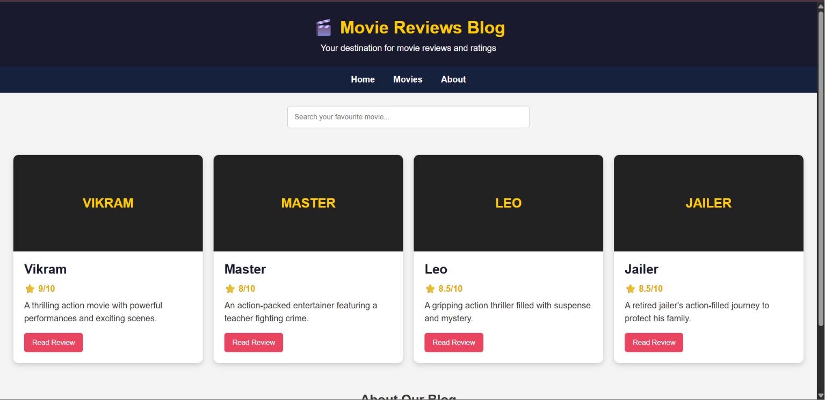

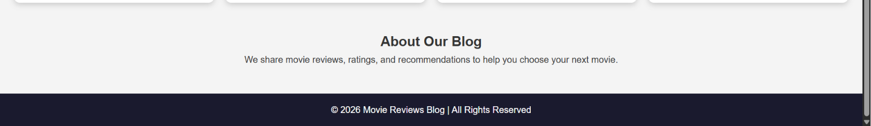

Result:
Thus, the Movie Reviews Blog website was successfully designed and developed using HTML, CSS, and JavaScript with movie ratings, search functionality, show/hide reviews, navigation links, and a responsive user interface.

